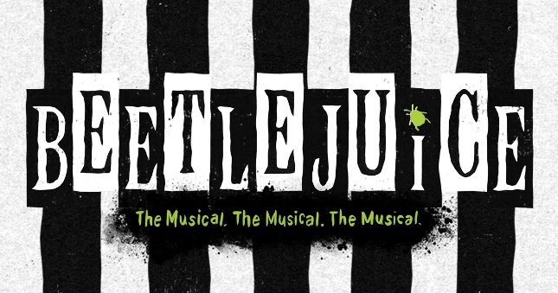
EASTER
SCHOOL

Mon 13th to Fri 17th April 2026

We are delighted to announce another fun-filled activity week for 7 to 16 year-olds during the Easter holidays this year. Beetlejuice is based on the classic movie and the Broadway musical, which is shortly oming to the West End! It will be an action-packed musical adventure, featuring fantastic songs, dances and drama. As with past Summer Schools, such as Beauty & the Beast, MARY POPPINS and THE LION KING, the week will consist of daily classes in:

***Acting *** Singing *** Dancing***

- starting at 9.30am and finishing at 4.15pm. In addition to the three performance classes, there will be daily specialities, from props and scenery creation to make-up design. The whole week ends with a show on Friday afternoon, performed (free of charge) for family and friends.

The teachers this year will include Ian Trafford and Tanya Euridge, amongst others. The Easter School takes place at Stage Studios, which will be open each day from 8.45am, closing at 4.45pm. The standard cost of the Easter School week will be £250.00 per person. A non-refundable deposit of £25.00 is payable to secure a place on the activity week. The balance is payable by 1st April 2026.

 EARLY PAYMENT DISCOUNT 
£25.00 DISCOUNT FROM THE TOTAL
(£225 instead of £250)
IF £25.00 DEPOSIT IS PAID BY 5th DEC 2025

If you would like to book a place, please complete the slip below. Further details and timetables will be issued in early April. Since space is limited, all places will be filled on a first come- first served basis. Early booking is advisable as spaces are strictly limited.



NAME ________________________________ AGE ______________________

EMAIL ADDRESS _______________________________________________________________

I would like to book a place on BEETLEJUICE Easter School from 13th to 17th April 2026.

I consent for ________________________ to participate. I will BACS a £25 non-refundable deposit.

Signed ____________________________ (parent/ guardian/ carer)

