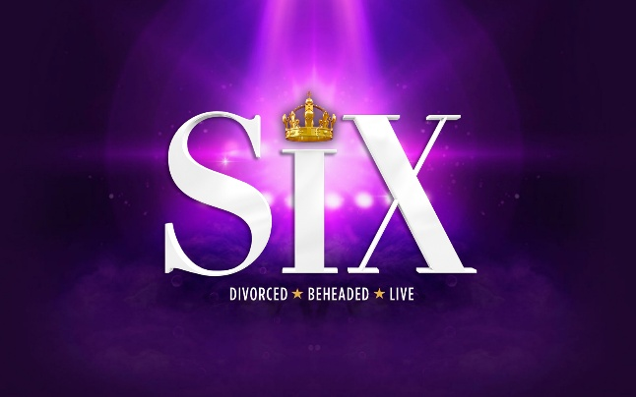
SUMMER
SCHOOL

Mon 10th to Fri 14th August 2026

We are delighted to announce another fun-filled activity designed for senior students aged 12 to 18 year-olds during the Summer holidays this year. SIX is based on the wonderful musical, featuring all the classic songs- with some extra material added for the boys! It’s the hit musical, featuring fantastic songs, dances and drama. As with past Summer Schools, such as Beauty & the Beast, MARY POPPINS and THE LION KING, the week will consist of daily classes in:

***Acting *** Singing *** Dancing***

- starting at 9.30am and finishing at 4.15pm. In addition to the three performance classes, there will be daily specialities, from props and scenery creation to costume design. The whole week ends with a show on Friday afternoon, performed (free of charge) for family and friends.

The teachers this year will include Ian Trafford and Tanya Euridge, amongst others. The Summer School takes place at Stage Studios, which will be open each day from 8.45am, closing at 4.45pm. The standard cost of the Summer School week will be £275.00 per person. A non-refundable deposit of £25.00 is payable to secure a place on the activity week. The balance is payable by 1st July.

 EARLY PAYMENT DISCOUNT 
£25.00 DISCOUNT FROM THE TOTAL
(£250 instead of £275)
IF £25.00 DEPOSIT IS PAID BY 5th FEB 2026

If you would like to book a place, please complete the slip below. Further details and timetables will be issued in early June. Since space is limited, all places will be filled on a first come- first served basis. Early booking is advisable as spaces are strictly limited.



NAME ________________________________ AGE ______________________

EMAIL ADDRESS _______________________________________________________________

I would like to book a place on SIX! Summer School from 10th to 14th August 2026.

I consent for ________________________ to participate. I will BACS a £25 non-refundable deposit.

Signed ____________________________ (parent/ guardian/ carer)

